MOBILE APPLICATION DEVELOPMENT PROJECT LOGBOOK
Student Name: Kelvin Maina
Admission Number: BIT/2025/67697
School/Faculty: School of Computing and Informatics
Programme: Bachelor of Information Technology
Academic Year: 2025/2026
Semester: 3.1
Lecturer: Michael Nyoro
Phone Number: 0787730624
Project Title: Kagema Comprehensive School Management App

TABLE OF CONTENTS

Week 1: Introduction to Mobile Application Development ................. 2
Week 2: Mobile Development Environment ...................................... 8
Week 3: User Interface Design ......................................................... 10
Week 4: Event Handling and User Interaction .................................... 12
Week 5: Data Management ...............................................................14
Week 6: Networking and APIs .......................................................... 16
Week 7: Storage Method ...................................................................18
Week 8:Events handling....................................................................20

Week 1: Introduction to Mobile Application Development

- Downloading android studio
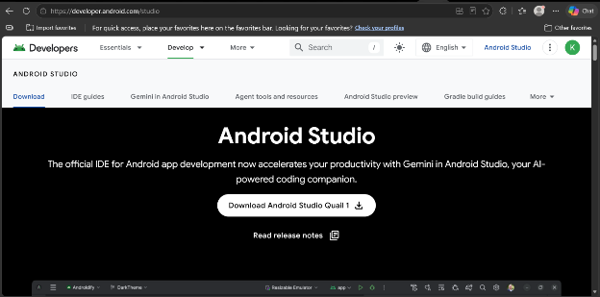

Android studio installation screenshpt
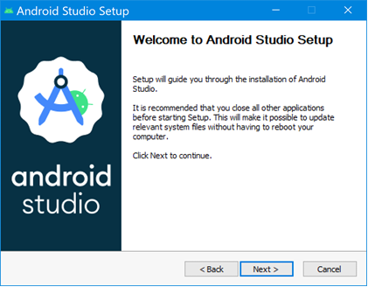

Flutter Doctor Output

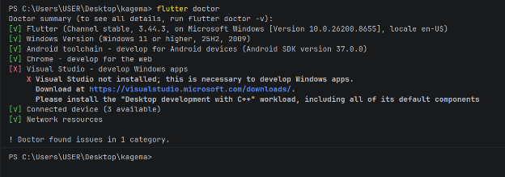

Avd_manager screenshot
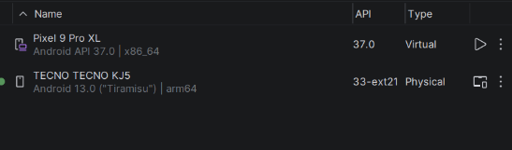

Created Android Virtual Device (AVD).
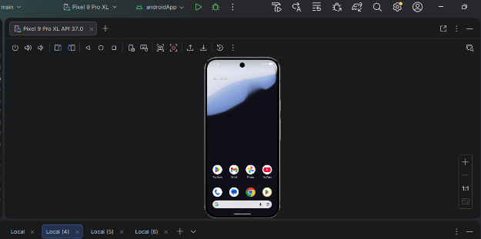

Flutter Project Structure

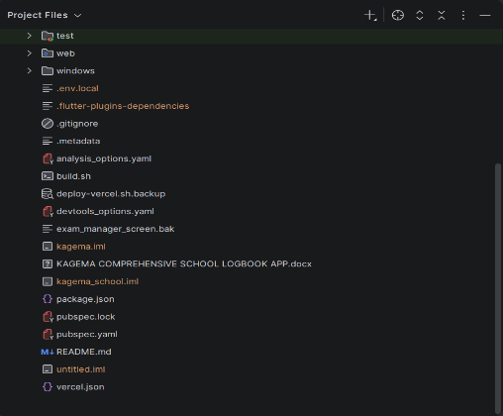

GitHub repository screenshot

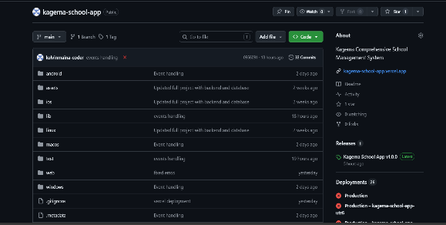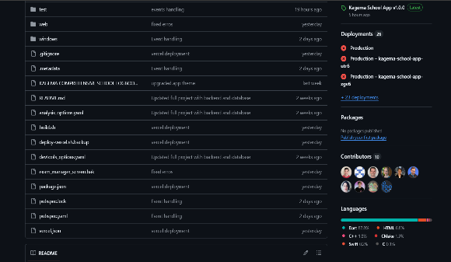

Version Control Setup screenshot
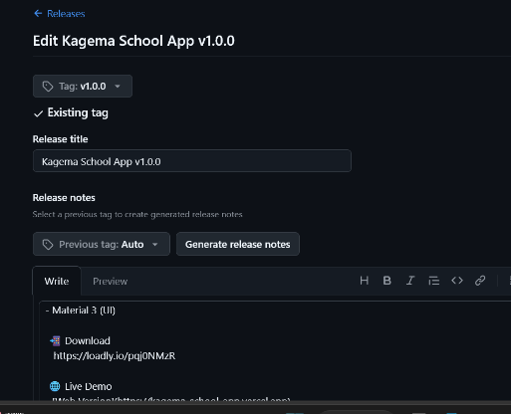

Week 2: Mobile Development Environment

Fast app Running screenshot

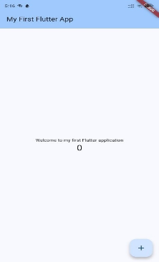

Flutter app running on emulator screenshoot

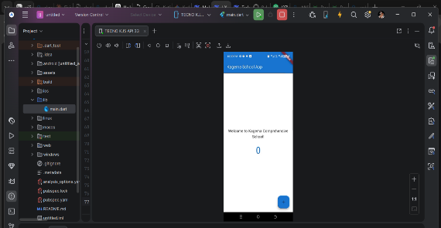

Week 3: User Interface Design
login and dashboard screens figma screenshots

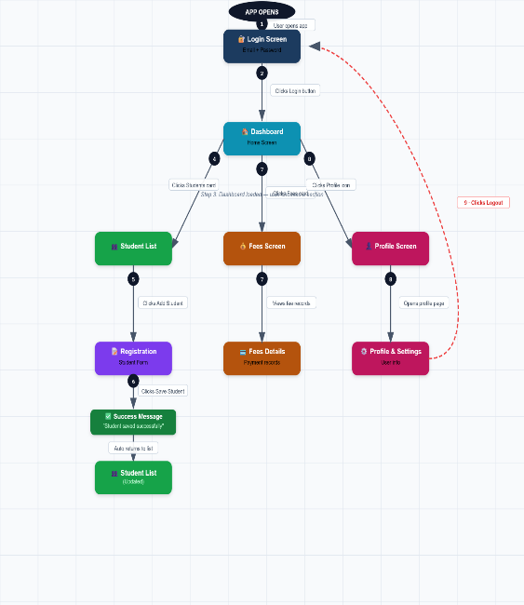

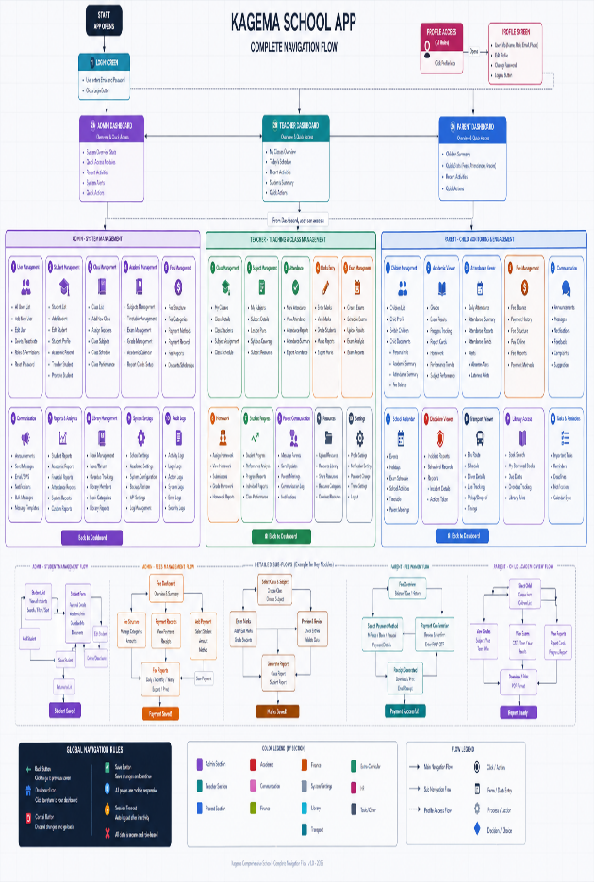

Week 4: User Interaction
app screenshot user interaction
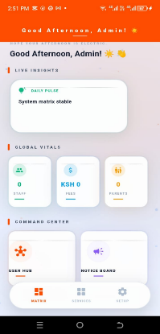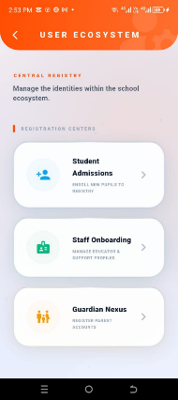

User interactions screenshot screens
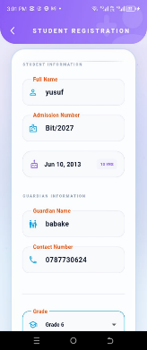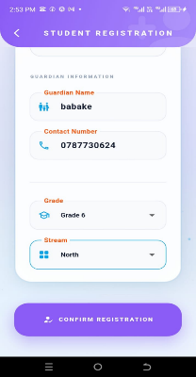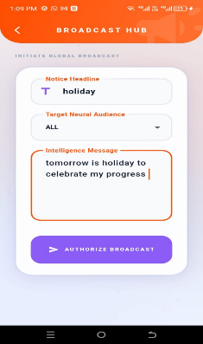

Week 5: Data Management
Student data management screenshot
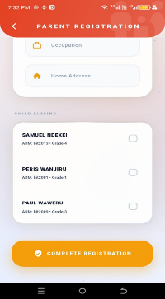

Database student management screenshot
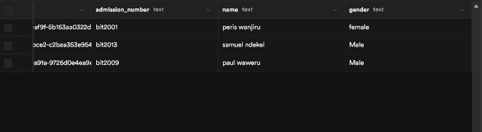

Editing feature screenshot
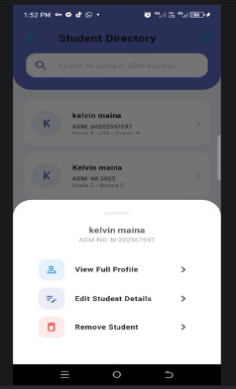

Week 6: Networking and APIs
Supabase apis screenshot

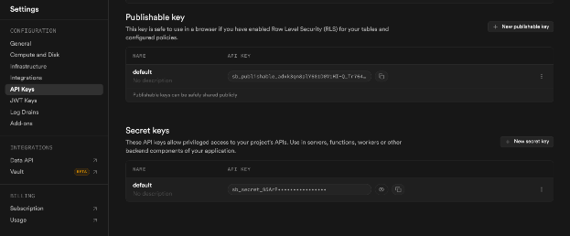
url api supabase screenshot
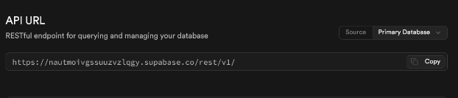
Pesapal payments api screenshot
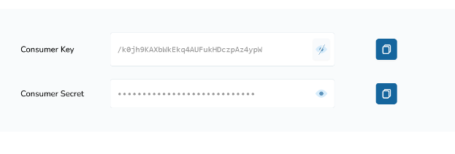

Week 7 : Storage Method Comparison

Database Design screen shot
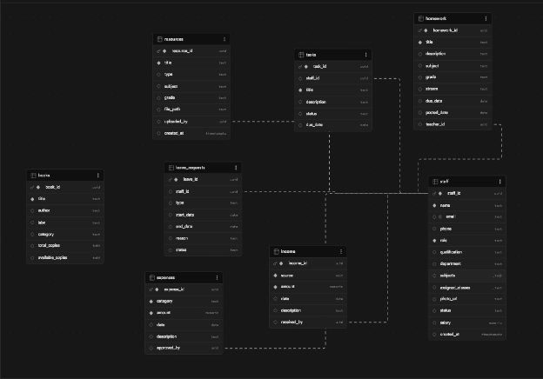

Profile Screen Screenshot

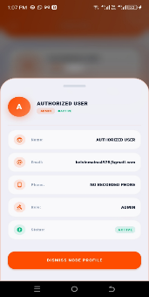

Week 8 Events handling
Login screen showing user input fields (email and password)"

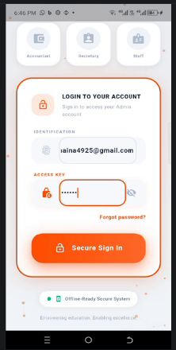

login form showing validation errors

41
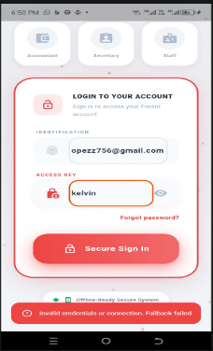

Admin dashboard with interactive touch elements screenshot
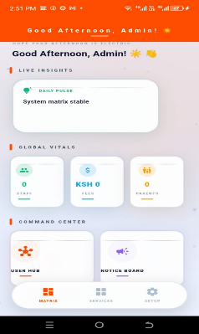
Student registration form showing input fields event handling screenshot

